MINOR PROJECT VALIDATION FORM

Supervisor Name |  | Panel Head
 | Dr. Naveneet Nayan | Dr. M. Ferni Ukrit
 | Faculty Advisor | Project Domain
 | - Dr. S. Suresh Kumar  - Dr. G. Tamilmani | Research
M
 | Student(s) Details: Name | Passport size photo(s)
- Priyanshu Kumar Singh
- Aastha Hotwani

Registration Number(s)

1. RA2311033010088
2. RA2311026010389

Email ID(s)&Mobile Number(s)
1: ps6046@srmist.edu.in & 7702674901 | 2: ah8790@srmist.edu.in & 7415219808
3: | 4:

1 | Abstract | - AI-based Visual Cognitive Coding Assistant to improve DSA skills.  - Analyzes students’ partial or incorrect Python code instead of giving direct solutions.  - Identifies repeated mistakes and individual coding patterns.  - Creates personalized learning profiles for each student.  - Provides guided feedback with visual explanation of optimization and time complexity.  - Supports multilingual learning for better understanding.
2 | RESEARCH GAP  (not more than 3 points) | - Most AI coding tools provide complete solutions instead of improving students’ problem-solving skills.  - Existing platforms do not analyze the student’s thinking process while coding.  - Current systems lack personalized learning profiles based on coding behavior and repeated mistakes.
3 | Please furnish the details of 5 research articles in IEEE Reference format with Impact factor and year of publication from Which Research gap has been identified (F. Lastname, “Title of article,” *Journal Name*, vol., no., pp., year. And IF 3.1)) / 5 Patent Details for highlighting the innovation | - Aggarwal et al., “Evaluation of Large Language Models in Programming Contests,” IEEE Access, vol. 12, pp. 45012–45025, 2024. IF: 3.9  Research Gap: No cognitive learning analysis of students.  - Liang et al., “Performance Evaluation of LLM-Generated Code Using Runtime Validation,” IEEE Transactions on Software Engineering, vol. 50, no. 3, pp. 1021–1034, 2024. IF: 6.7  Research Gap: Lacks student behavior tracking.  - Xie et al., “Execution-Free Runtime Error Detection Framework,” IEEE Transactions on Reliability, vol. 73, no. 1, pp. 155–168, 2024. IF: 5.0  Research Gap: No adaptive learning feedback.  - Li et al., “Analyzing Programming Errors using LLM Reasoning,” IEEE Intelligent Systems, vol. 39, no. 2, pp. 60–69, 2024. IF: 4.1  Research Gap: No personalized learner modeling.  - Wang et al., “Self-Correcting AI Coding Systems,” IEEE Transactions on Learning Technologies, vol. 16, no. 4, pp. 580–592, 2023. IF: 4.8  Research Gap: Missing visual reasoning and long-term learning analysis.
4 | Bridging the Research Gap/ Innovation Gap  (not more than 3 points) | - Cognitive Learning Focus – The system analyzes students’ coding behavior and thinking patterns instead of only generating solutions.  - Personalized Adaptive Learning – Builds individual learning profiles by tracking repeated mistakes and progress over time.  - Integrated Intelligent Tutoring – Combines error prediction, visual algorithm explanations, and multilingual guidance in a single AI learning platform.
5 | OBJECTIVE  (not more than 5 points) | - Develop an AI-based cognitive coding assistant for DSA learning.  - Analyze students’ partial or incorrect code instead of giving direct solutions.  - Build personalized learning profiles based on coding patterns and mistakes.  - Provide visual explanations and optimization guidance for better understanding.  - Support multilingual learning to improve accessibility and placement preparation.
6 | System Architecture | 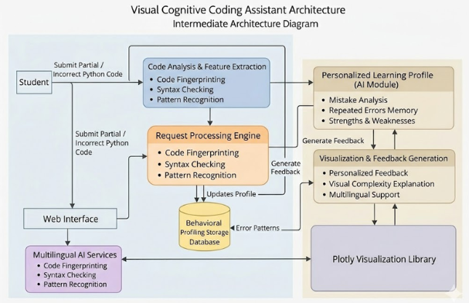
7 | METHODOLOGY  (not more than 10 points) | - Collect student Python code submissions.  - Perform code preprocessing and syntax validation.  - Detect logical, syntax, and optimization errors.  - Analyze student coding behavior and patterns.  - Create personalized learner profile.  - Learning Agent tracks progress and adapts feedback.  - Generate guided hints instead of full solutions.  - Provide visual explanation of algorithms & time complexity.  - Support multilingual explanations for better understanding.  - Store learning history for continuous improvement and performance tracking.
8 | OUTCOMES OR DELIVERABLES  (not more than 5 points) | - AI-based Visual Cognitive Coding Assistant prototype.  - Personalized student learning profile with mistake analysis.  - Guided feedback system without providing direct solutions.  - Visual explanation module for algorithms and time complexity.  - Multilingual coding learning support for placement preparation.
9 | NOVELTY  (not more than 3 points) | - AI-based Visual Cognitive Coding Assistant prototype  - Personalized Learning Agent for student performance tracking  - Automated mistake pattern analysis & feedback system
10 | Time line | Deliverables
 | February 21, 2026 (SPRINT Review 1) | • Problem analysis completed  • Literature survey finalized  • System architecture & module design
 | March 22, 2026 (SPRINT Review 2) | • Prototype development completed  • Learning Agent integration  • Initial testing & feedback system
 | April 28 – 30,2026 (Project Demo and Report submission) | • Final AI Coding Learning Platform  • Predictive feedback & personalization module  • Final report, demo & documentation
11 | Collaboration details | - 1. Academic Mentor Collaboration – Guidance on research methodology, validation, and evaluation.  - Technical Collaboration – Support for AI tools, coding platforms, and Agile-SCRUM based development.
12 | Target Technology Readiness Level of the project  (TRL Scale 1 to 9)  TRL 1 -Basic principles observed and reported.  TRL 2 -Technology concept formulated.  TRL 3 -Experimental proof of concept.  TRL 4- Technology validated in lab.  TRL 5- Technology validated in a relevant environment.  TRL 6 -Technology demonstrated in a relevant environment.  TRL 7- System prototype demonstration in operational environment.  TRL 8- System complete and qualified.  TRL 9- Actual system proven in operational environment.
13 | Sustainable Development Goal (1-17) (Most prominent one goal) | SDG 4 – Quality EducationSDG 4 – Quality Education  The project promotes inclusive, personalized, and technology-enabled learning by improving students’ coding and problem-solving skills through AI-based cognitive tutoring and multilingual support.
14 | Industry Practice followed for system development (Agile- SCRUM) | - Requirement gathering through user stories and sprint planning.  - Development divided into short iterative sprints.  - Continuous coding, testing, and integration in each sprint.  - Regular sprint reviews and feedback incorporation.  - Daily SCRUM meetings for progress tracking.  - Incremental feature development and deployment.  - Continuous improvement through retrospective meetings.

Conference/Journal Publication/Patent Details :
Annals of R.S.C.B., ISSN:1583-6258, Vol. 25, Issue 6, 2023

Signature of Students:
1. Priyanshu Kumar Singh
2. Aastha Hotwani

Signature of the Supervisor:

